Ericsson Order Care - Life Cycle Plan
Contents
1 Introduction 4
2 Ericsson Order Care Product 5
2.1 General 5
2.2 Basic Principles for the Life Cycle Plan 5
2.2.1 Concepts Used in this Document 5
2.2.2 Product Major Version 6
2.2.3 Product Minor Version 6
2.2.4 Product Patch Version 6
2.3 Patch Policy 7
3 Current Life Cycle dates 8
4 List of Abbreviations 9
5 Appendix 10
5.1 Historic product names 10

Revision history
Rev A | 2014-04-30 | Fareed Khan | First approved version, for Order Care 14.0 release.

Introduction
This document provides information on Life Cycle dates for the Ericsson Order Care product. It is mainly intended for people directly interfacing with customers. This document provides Ericsson’s consolidated view on these dates. It may be handed over to a customer as long as there is no need to adapt the information to market specific conditions.
The document covers delivery and support dates for the Ericsson Order Care product software. It also clarifies the difference between maintenance and support.
Ericsson’s commitment and obligations are governed by supply and support contracts. The Life Cycle Plan is designed to support this work.
The Life Cycle Plan reflects the current planning and may be subject to change.
This Life Cycle Plan is consolidated within Ericsson. Internal plans and processes are aligned to fulfill the Life Cycle Plan on a global level. Local variations may apply.
Definitions of Ericsson concepts used in the document and a list of abbreviations are provided in this document.

Ericsson Order Care Product

General
Ericsson Order Care consists of software only. Hardware is not part of the delivery or support plans. Some third party product software is embedded and the statements in this document apply for this software as well. Other third party software is listed as pre-requisites for Ericsson Order Care, but is not embedded. For example, the Operating System and Database are not covered in this document.
In short, the Life Cycle Plan covers only the software that is included in the Ericsson Order Care delivery. For more details, see Ordering Guidelines in the product catalogue. The product package expansions refer only to the right to use the software for a larger number of end-users. This package is in theory available for delivery until End of Life, since it requires no physical delivery. However, it is still recommended to upgrade to a more recent version of the software, especially with a growing end-user count.
The current version of Ericsson Order Care is 5.2. It will have corresponding patch releases, according to section 2.3 Patch Policy.

Basic Principles for the Life Cycle Plan
To understand the rationale behind set dates in the Ericsson Order Care and related products Life Cycle plan, it is important to understand some basic principles that are generally applied (deviations may occur).
As soon as any new major or minor version of Ericsson Order Care is released (PRG), that version will be the only orderable and deliverable release. This will also trigger Last Time Buy (LTB) and End of Delivery (EoD) for the previous release. This is also labeled as the obsolescence phase.

Concepts Used in this Document
End of Tender — N/A. See Last Time Buy.
Last Time Buy (LTB) is the last date to finalize an order in the ordering system. The LTB date for a release is set to the 30 days after the General Availability (PRG) date for the next release (Order Care n + 1). After this date, it is only possible to order new sales on the latest Ericsson Order Care release. This is normally aligned with EoD, with a one month separation.
End of Delivery (EoD) is the last date when a product is shipped from Ericsson. The EoD date for a release is set to one month after LTB. The only commercial object that will remain deliverable is Expansions. Patch releases and emergency corrections are still released according to patch policy. This is also labeled as the obsolescence period.
End of Maintenance (EoM) of an Ericsson Order Care release is set to 36 months after PRG of the release. EoM means that the third line support provided by the Product Line Maintenance (PLM) organization has ended and no TR investigation nor fault mapping is performed. Correction packages are not provided. EoM is combined with EoS.
End of Support (EoS) is end of first and second line support. EoS for Ericsson Order Care is set to 36 months after PRG of the release. At this point, no CSR can be sent to Global Support. The customer must have upgraded to a newer release of the product to have continuing support. Deviations may occur on a request basis, meaning that first and second line support can be offered for a release that is no longer maintained, but is considered stable, and belongs to a product family which still has an active roadmap. For Order Care, the exemption criteria are set to require a continuous substantial business for Ericsson. Exemptions for support past the 36 months release Life Cycle will be very rare. EoS is combined with EoM.
End of Life (EoL) indicates termination of the product release at Ericsson. Documentation, hardware, software, and so on is canceled (scrapped).

Product Major Version
A major product version is characterized by significant new product features and new or revised interfaces and APIs. A major product version is not guaranteed to be backwards compatible with older versions of the same product.

Product Minor Version
A minor product version is characterized by little or no new product features and contains 100% backward compatible interfaces and APIs. It is considered essential that existing customers can upgrade effortlessly.

Product Patch Version
A patch version is characterized by no new roadmap driven product features and 100% forward and backward compatible interfaces and APIs. Product customizations are delivered as part of patch releases. It is considered essential that existing customers can upgrade and downgrade effortlessly, that is, upgrading by copying new binaries/libraries into an existing installation and restarting. It should not be necessary to create a new or edit an existing configuration file. Product patch versions are considered to be obsolete one month after the next product patch version is made available.

Patch Policy
A detailed description on how patches are categorized, bundled, distributed, and installed can be found on the Ericsson Order Care support Web. In short, the frequency at which patch bundles are being released follows this rule.
Time After GA | Patch Bundle Release Frequency | Comment
0 – 3 months | 1 release every month | If needed
3 – 12 months | 1 release every third month | If needed
1 year – End of Maintenance (EoM) | Based on demand | Only short term release schedule available

Current Life Cycle dates

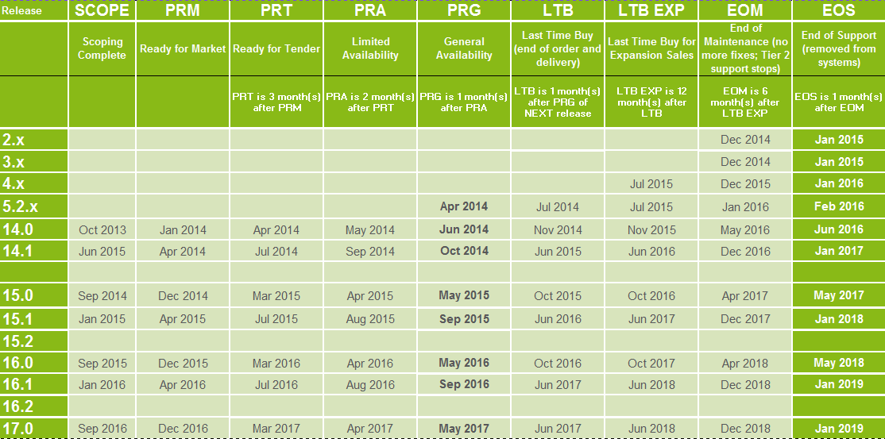
Legend: Committed date
Indicative date

List of Abbreviations
CC Competence Centre
CIC Customer Interaction Centre
CSR Customer Support Request
RDBMS Relational Database Management System
ELS Ericsson Local Support
EoD End of Delivery
EoM End of Maintenance
EoS End of Support
GA General Availability
GSD Global Service Delivery
HW Hardware
LCP Life Cycle Plan
LTB Last Time Buy
Order Care Ericsson Order Care
PRG General Availability
PRM Ready for Market
PRT Ready for Tender
SLA Service Level Agreement
SW Software

Appendix

Historic product names
The Ericsson Order Care was previously referred to as ConceptWave Order Care. It is considered to be the same product, regardless of the name change.

